Airline Data Management and Analysis using Power BI

- Name – Amisha Tripathy
- Submission Date- 16-08-2025
- Batch- 01st june

- Objective: (Mention data analysis, visualization, improving efficiency & satisfaction).
Problem Statement: The airline industry operates with numerous complexities, requiring effective data management and insights into flight schedules, passenger details, and ticketing systems. This project aims to analyze airline operations for improving efficiency and customer satisfaction.

Task 1 – Data Preparation & Cleaning
Extract and transform data in Power Query. Clean data: remove duplicates, handle missing values, and format columns.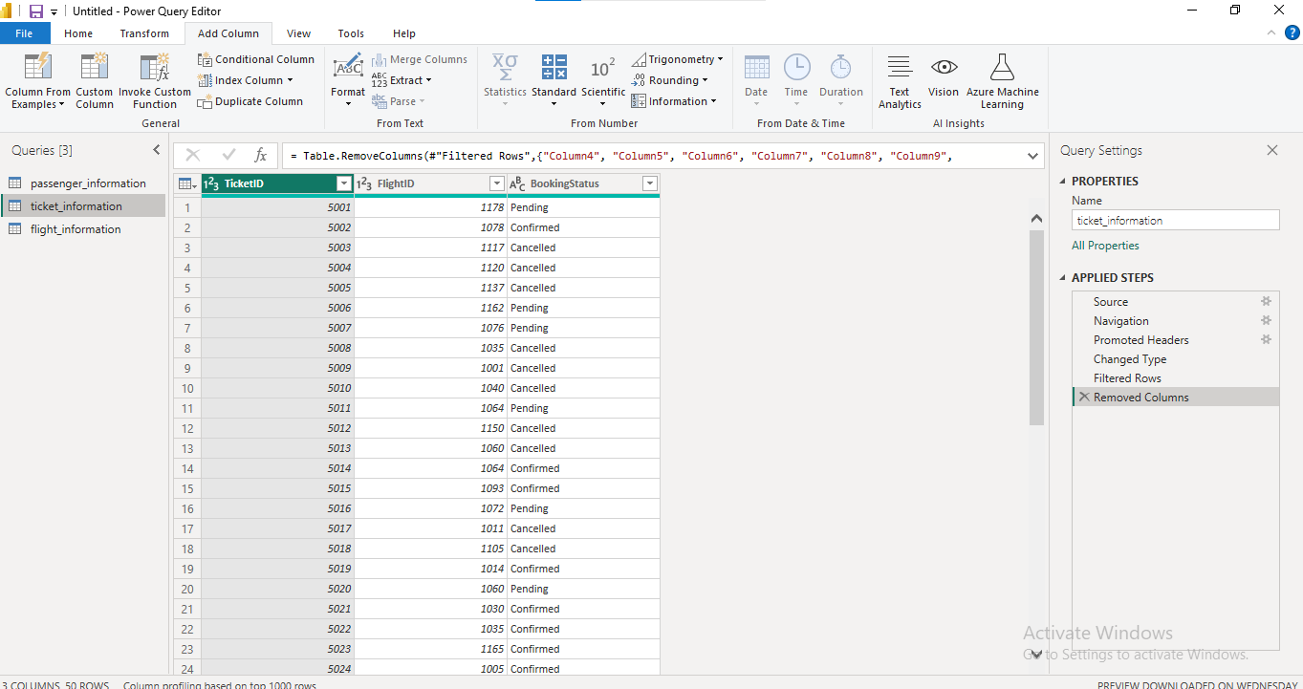 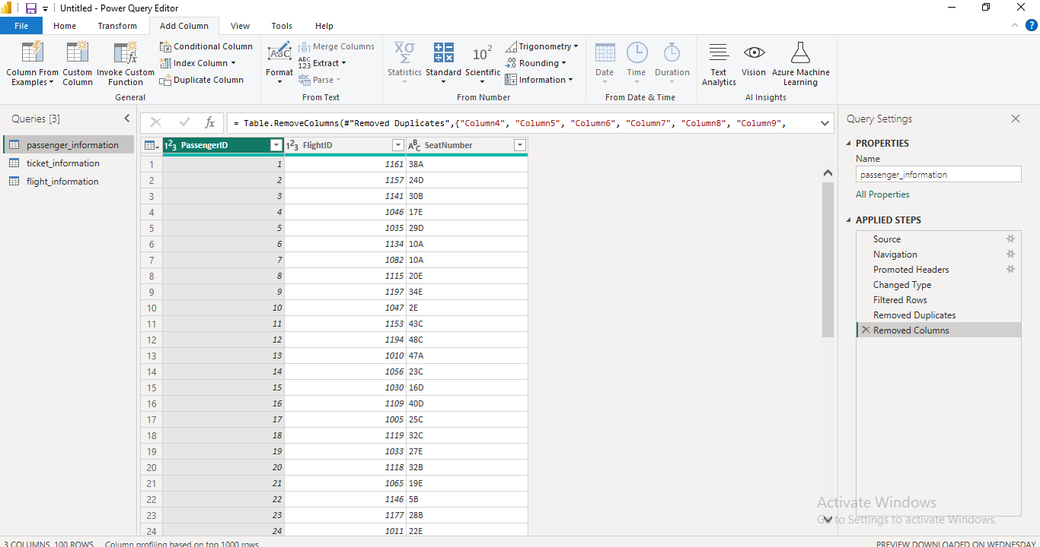
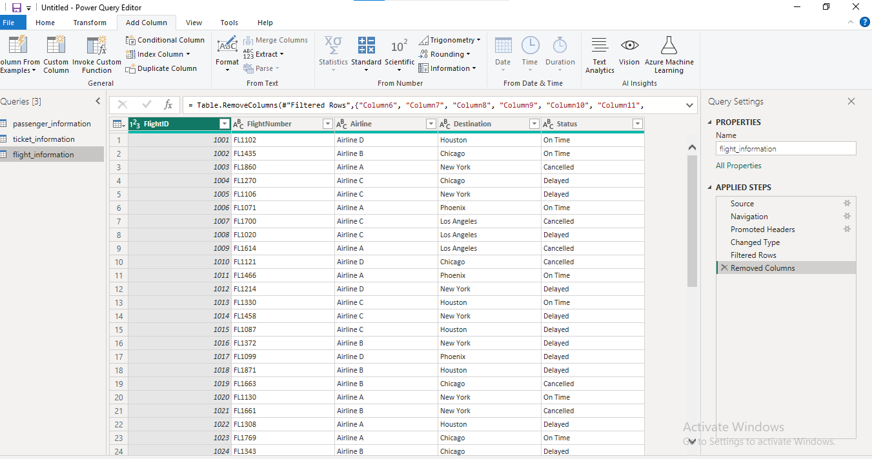 In this Task-1 The datasets were loaded into Power Query Editor for cleaning. Duplicates were checked but not removed, as repeated values in Flight Number, Destination, Flight ID, Airline, and Status were valid. Columns were formatted to the correct data types, and missing or unusable values were cleaned or replaced to ensure data consistency.

Task 2 – Data Modeling
Create relationships between datasets, Understand cardinality and configure the model appropriately
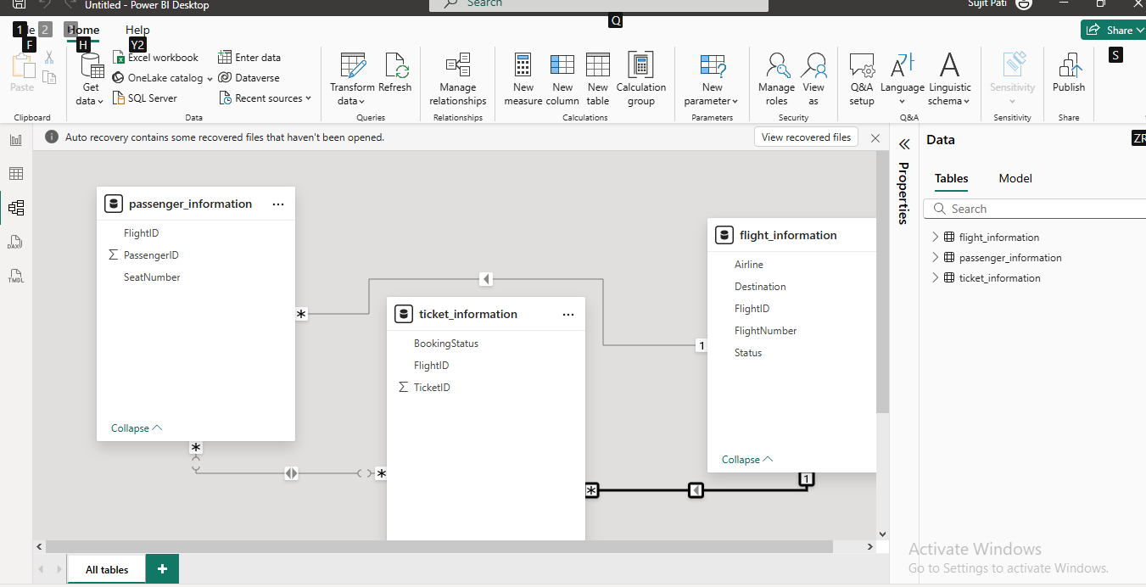

In Task-2 n Task 2, created relationships between all datasets based on common fields, including many-to-many, one-to-many, and many-to-one.

Task 3 – Enhanced Data Insights

Add a conditional column to classify flights as "Best" or "To Be Improved" based on status.
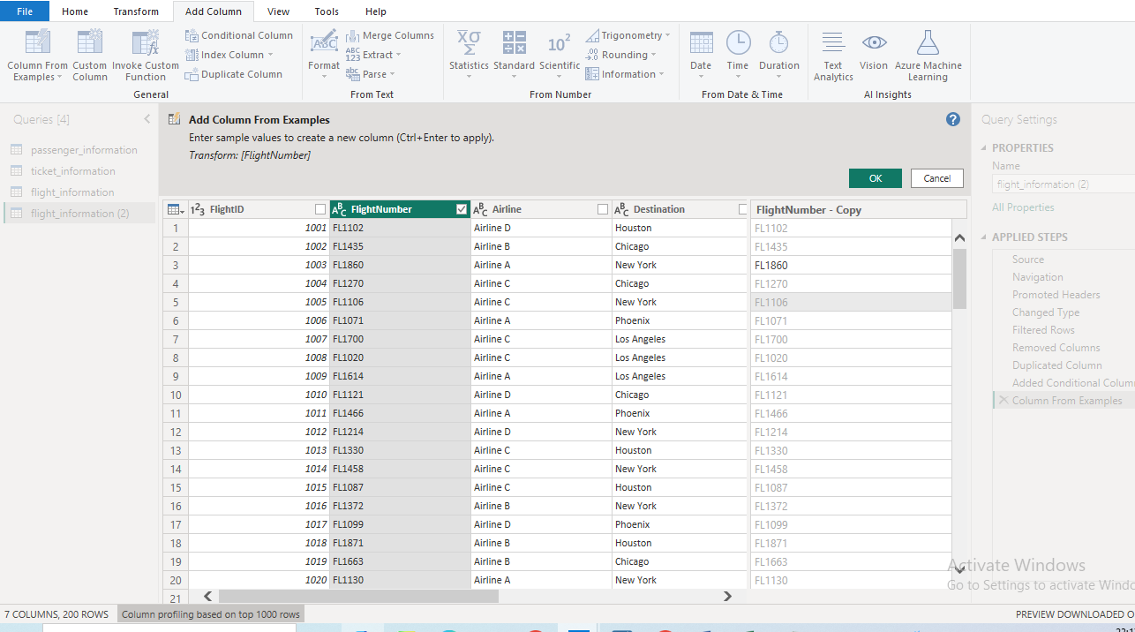

● Use "Column from Examples" to extract the flight
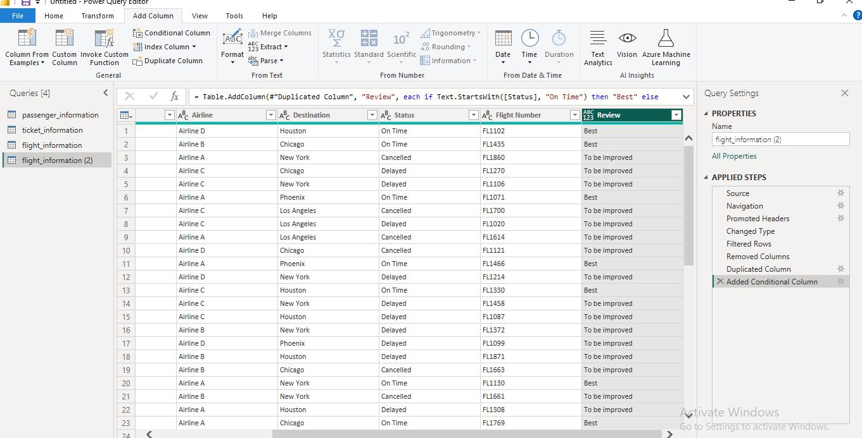
In Task-3 In Task 3, used a conditional column to classify flights as “BEST” or “TO BE IMPROVED” based on set criteria, and created another column from an example to extract the flight number.

Task 4 – DAX Calculations
Calculate: Total passengers for a specific flight
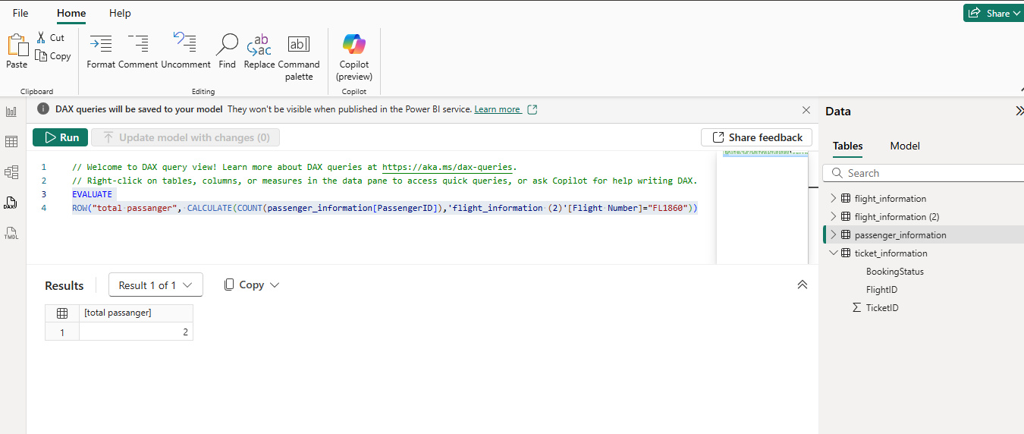 Total tickets booked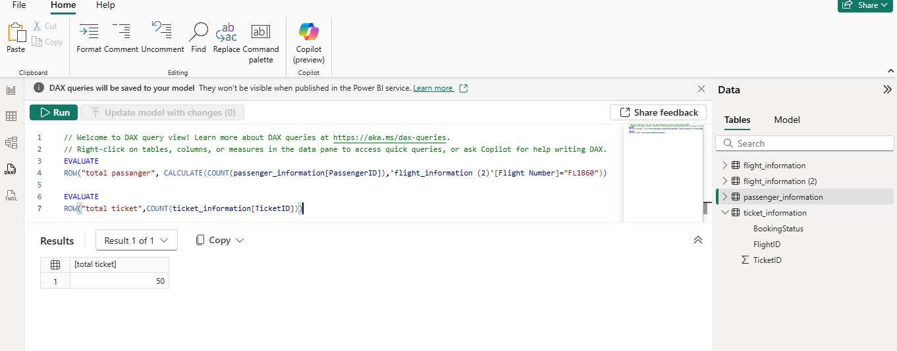Filtered table showing "Best" flights only. 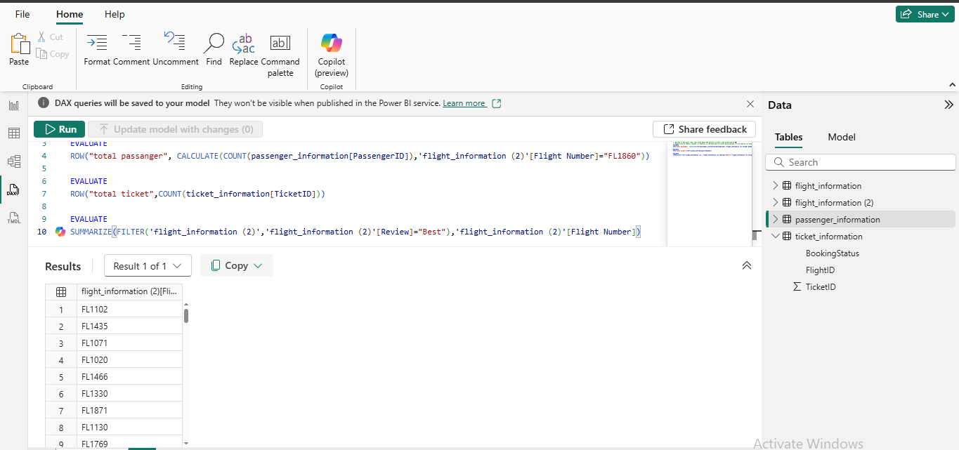
In Task-4 using DAX function to calculate and count total passenger, total flight, and only best flights.
.
Task 5 – Visualizations & Interactive Features
Create visuals for:
○ Passenger count by airline.
○ Ticket booking status.
○ Flights by airline and destination.
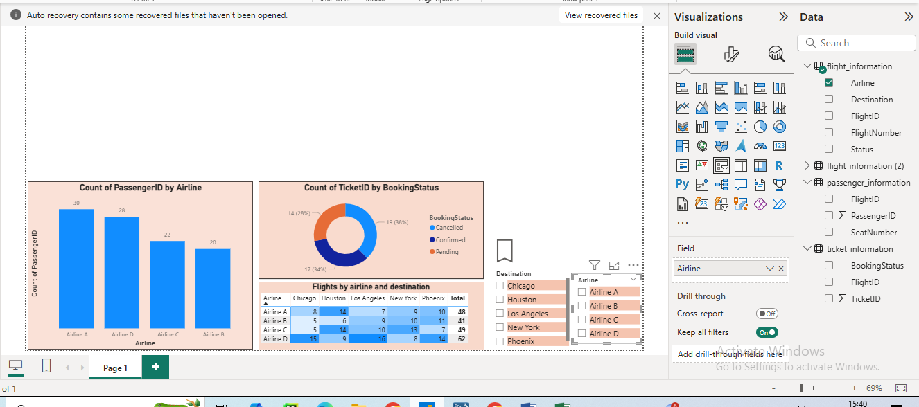
● Add interactive features for:
○ Destination and Airline.
○ Quick views.
○ Airline-specific pages 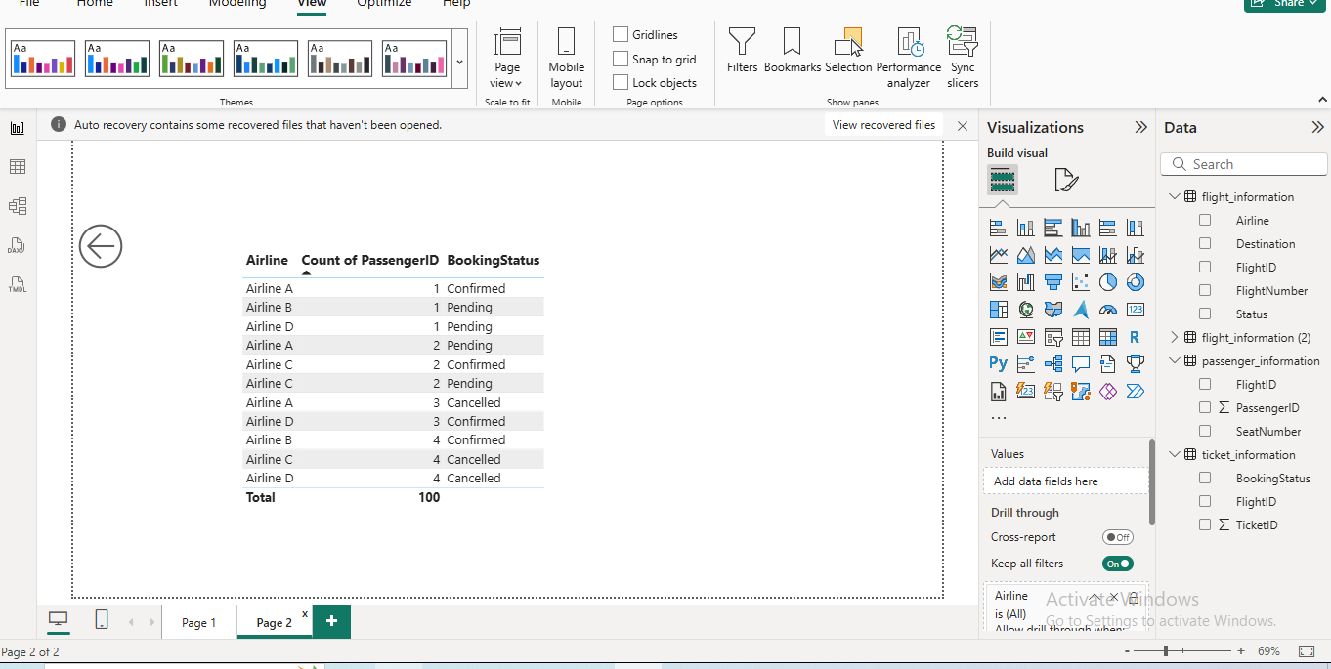 In Tsk-5 n Task 5, created visuals based on problem statements, added bookmarks for quick access to specific data, and enabled drill-through to view detailed data on another sheet..
Task 6 – Final Dashboard & Power BI Service
Design a comprehensive dashboard with key visuals and insights.
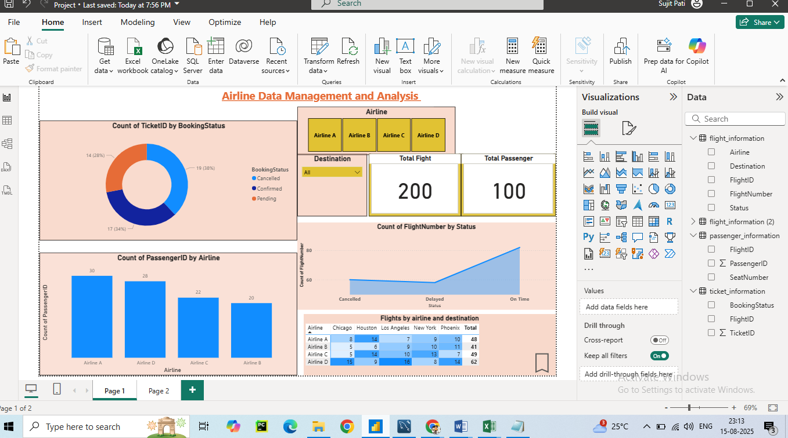
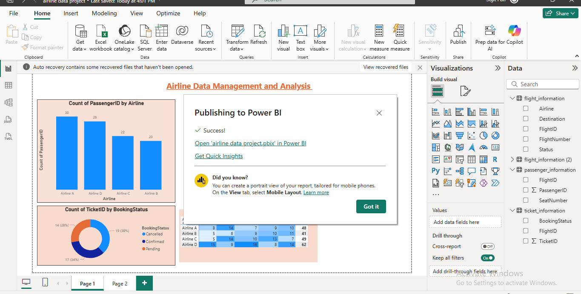

● Configure Row-Level Security (RLS) for Airline A data and assign it to a user.
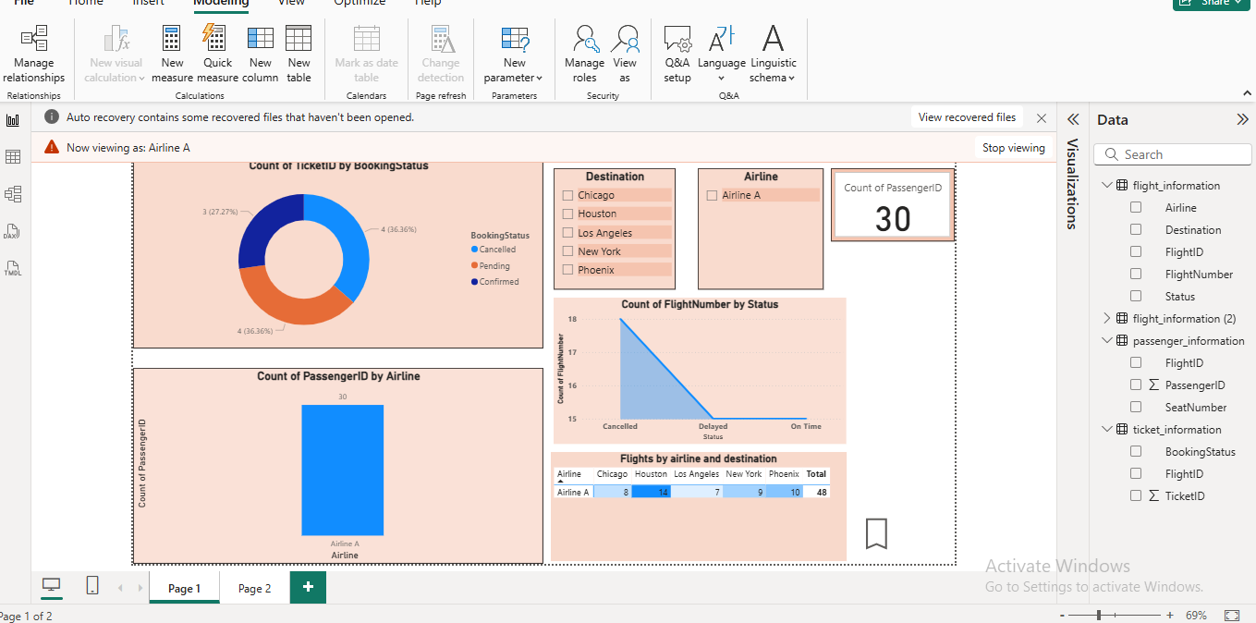
● Set up a schedule refresh at 5 PM daily
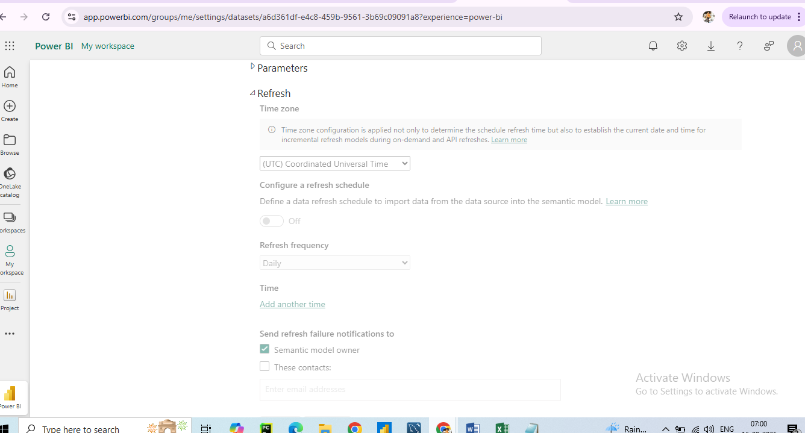
Due to the unavailability of Power BI Service access in my current environment, I was unable to configure and demonstrate the scheduled refresh at 5:00 PM daily. All other parts of Task 6, including the final dashboard design and Row-Level Security (RLS) setup within Power BI Desktop, were completed successfully.

Conclusion
The analysis of the airline data provided valuable operational and customer insights. Based on the visualizations and calculations:
- Airline with Highest Passengers: Airline A recorded the largest number of passengers across the observed period, indicating a strong customer base and higher route demand.
- Booking Trends: Ticket bookings showed a peak during holiday seasons and weekends, suggesting that promotional campaigns during these periods can further boost sales.
- Flight Performance: Flights categorized as “Best” demonstrated higher on-time performance and consistent passenger counts, while “To Be Improved” flights showed delays or cancellations that could affect customer satisfaction.
How this analysis can help the airline:
- Targeted Marketing: Focus marketing efforts on high-demand routes and loyal passenger segments.
- Operational Efficiency: Allocate resources effectively to improve performance of underperforming flights.
- Revenue Optimization: Introduce dynamic pricing during high-demand periods to maximize revenue.
- Customer Retention: Enhance service quality for frequently booked flights to maintain and grow the customer base.

THANK YOU

